Preliminary Project Report (BSA Binding)
Client: University of Iowa (Paloma Giangrande)
November 30, 2016

Aaron Martin

Introduction
The project objective was to provide accompanying data for that which was reported previously in SensiQ Technologies Report PPR 16110901, “RNA Aptamers Binding Histone”. The purpose of this project was to determine if significant binding of aptamers to serum albumin was likely to occur, and if so to determine kinetic rate and equilibrium dissociation constants for RNA aptamers binding immobilized bovine serum albumin (BSA). SensíQ Pioneer FE was used to capture BSA at density comparable to immobilized histones previously reported, and test binding of three specific aptamers and one negative control aptamer. Assay procedures were the same as previously reported.

Methods

SensíQ Pioneer FE was used for SPR analysis with an assay buffer containing 10 mM HEPES pH 7.4, 150 mM NaCl, and 2 mM CaCl₂.

Immobilization of Histone Proteins
Bovine serum albumin (Sigma cat. # A3059) was immobilized on a high-capacity COOHV sensor at pH 4.5 in 10 mM sodium acetate buffer with 0.01% Tween-20 to prevent non-specific binding to the vial and sensor surface during immobilization. The proteins were immobilized following a standard amine coupling procedure where a mixture of EDC and NHS was injected to activate the surface carboxyl groups, and BSA was injected to react with and be coupled to the sensor surface. During BSA coupling immobilized protein density on the sensor surface was monitored by pausing injections to reach a surface density of BSA similar to that attained previously with histone proteins. Following BSA injection 1M TRIS pH 8 was injected last to deactivate remaining active carboxyl groups. Both test and reference channels were activated and treated with 1M TRIS, while BSA was injected only over the test channel during protein immobilization/coupling. Approximately 4300 response units (RU) of BSA was immobilized on the test channel (Figure 1).
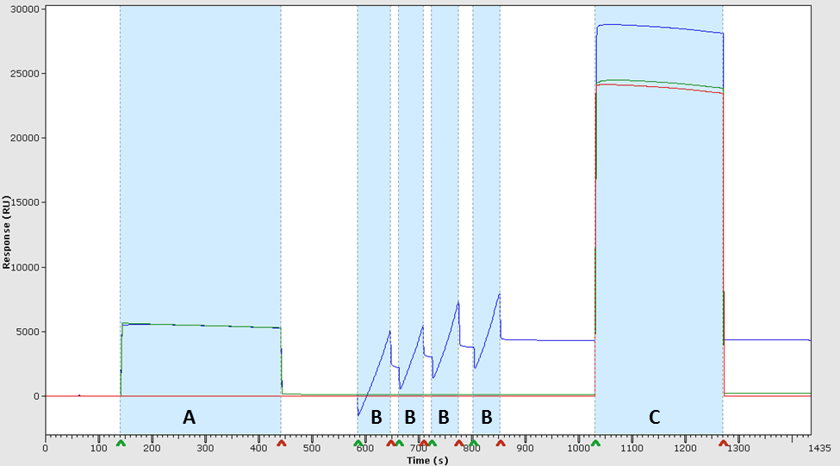
Figure 1 – Immobilization of bovine serum albumin (BSA). Reference and test channels are represented by green and blue curves, respectively. An additional channel (red) was completely untreated and used as a baseline for immobilization procedure. Injections are shown in highlighted areas. (A) Activation with EDC/NHS; (B) immobilization of BSA, pausing occasionally to control immobilized protein density on sensor surface; (C) Injection of 1M TRIS to remove remaining active groups.

Kinetic Assay
A dilution series was prepared for each aptamer in buffer to make: 100, 50, 25, 12.5, and 10 nM. Each sample was injected over all three flow channels for 4 min at a flow rate of 30 µL/min and dissociation was monitored for 10 min. The sensor surface was regenerated after each analyte cycle by injecting 1M NaCl for 1 min. Data were processed by subtracting the reference channel signal and buffer blank responses (double referencing method).

Experimental Results & Discussion

The experimental results indicated no significant binding of aptamers to immobilized BSA. Although there was a very low level of nonspecific binding in the reference channel (<5 RU) a similar response was observed in the test channel. Following proper referencing the next response was <2 RU. Sensorgram characteristics were similar in reference and test channels for aptamer analyte and buffer-only control injections, indicating observed response characteristics in scaled response plots in Figure 2 were primarily a function of bulk sample refractive index differences and not associated with a specific analyte-target interaction. This was supported by a small (<2 RU) difference in maximum response (R_{max}) between 10 nM and 100 nM analyte concentrations. Therefore, it is concluded that aptamers tested do not actively bind immobilized BSA under the assay conditions or at analyte concentrations tested. Since no binding was observed further kinetic analysis was not performed. The results shown in Figure 2 are scaled relative to lowest histone response (H4) previously reported for each aptamer in the previous report. For reference and comparison purposes, response plots and kinetic and binding data from the previous study are appended to this report.

Figure 2. Response plots from RNA aptamer injection over immobilized BSA. Plots are individually scaled to match scale of lowest-response histone (H4) plots previously reported. Color coding in plots is used to distinguish differing analyte concentration ranging from 10nM to 100nM.
APPENDIX – Data excerpted from SensiQ Report PPR 16110901

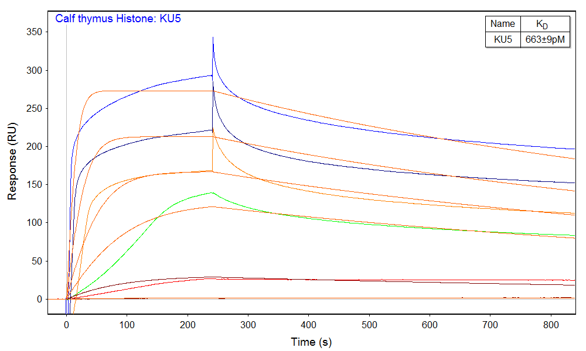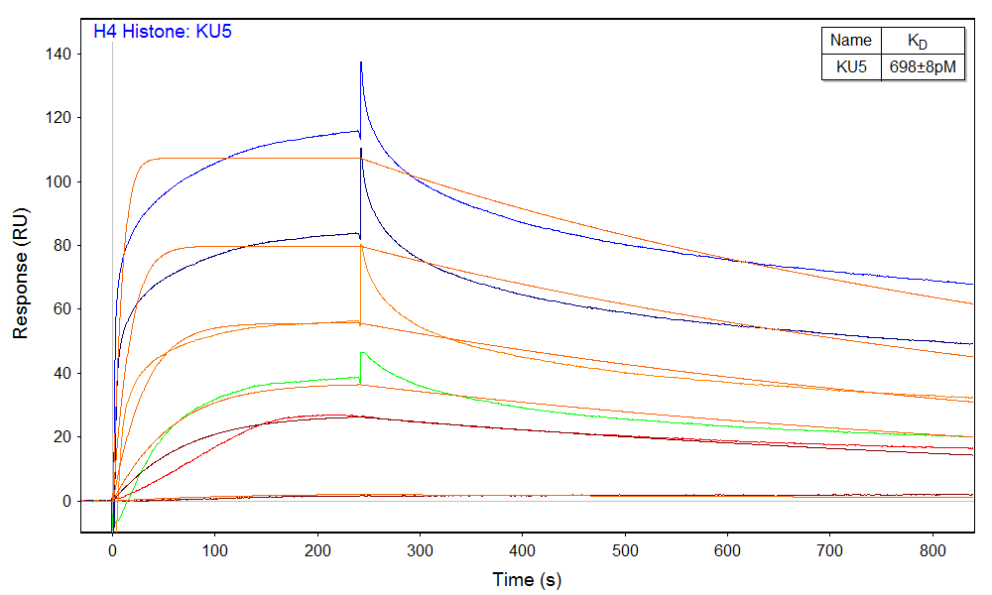
Figure 3 – Kinetic analysis of KU5 binding calf thymus Histone (left) and H4 Histone (right).
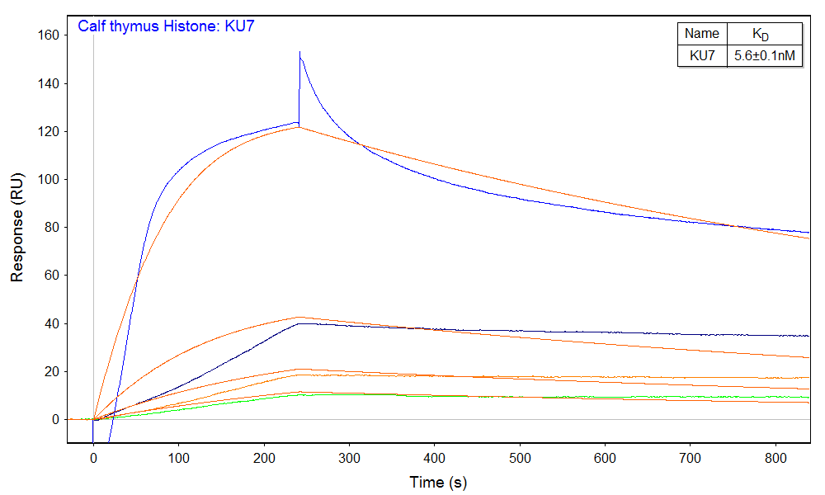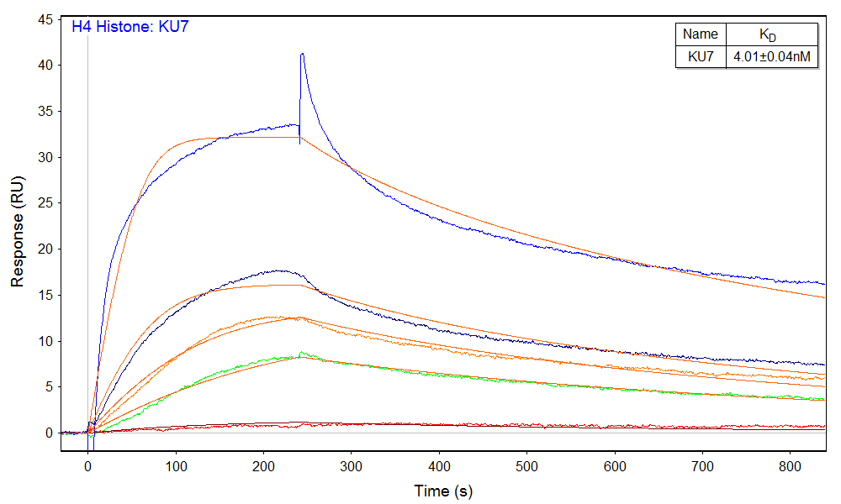
Figure 4 – Kinetic analysis of KU7 binding calf thymus Histone (left) and H4 Histone (right).
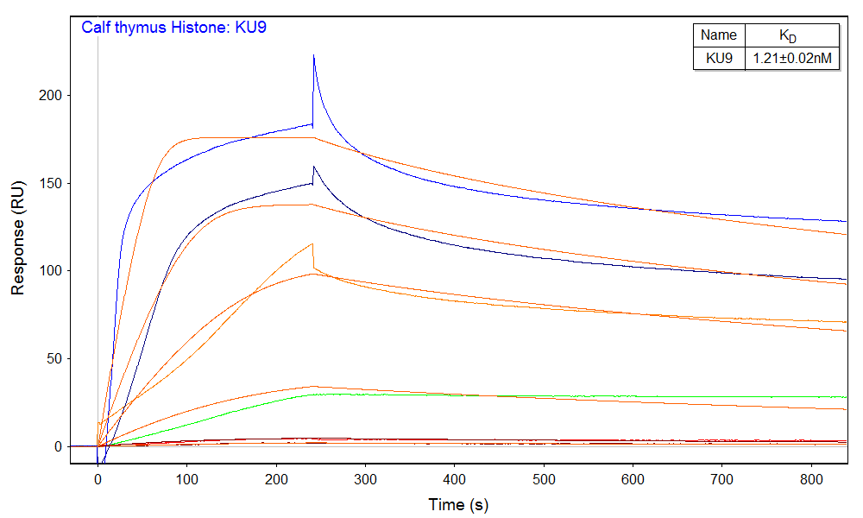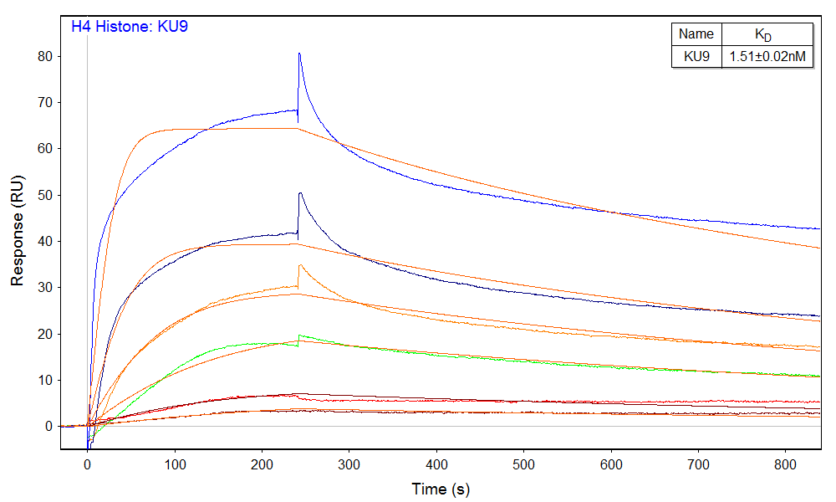
Figure 5 – Kinetic analysis of KU9 binding calf thymus Histone (left) and H4 Histone (right).
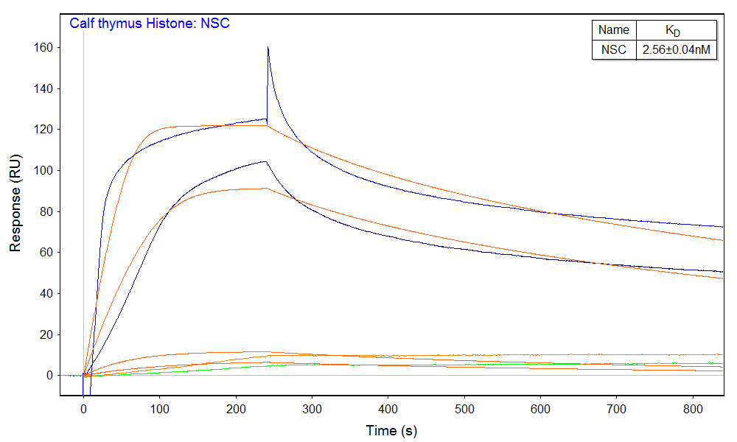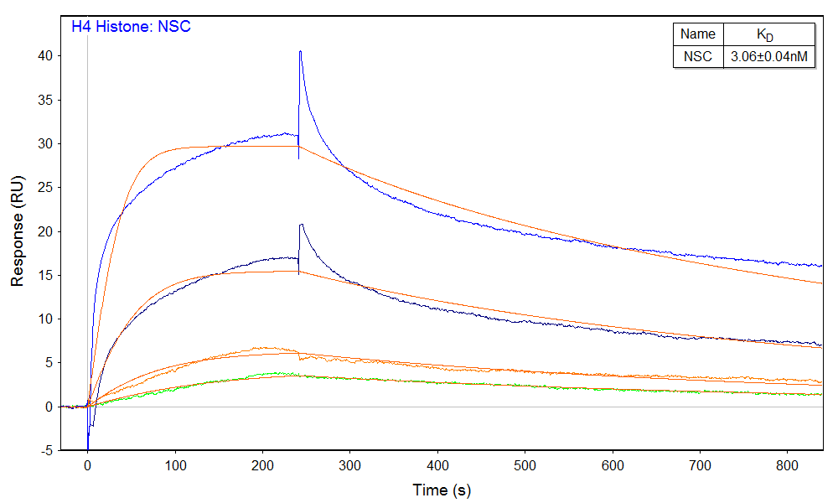
Figure 6 – Kinetic analysis of NSC binding calf thymus Histone (left) and H4 Histone (right).
Figures 3 – 6 show the binding responses of each aptamer binding the two Histone proteins. Color coding was used to illustrate the different analyte concentrations.

Table 1 – Kinetic rate constants for RNA aptamers binding Histone proteins
Analyte | Ligand | k_{a} (M⁻¹s⁻¹) | k_{d} (s⁻¹) | K_{D}
KU5 | Calf thymus Histone | 1.18±0.02e6 | 7.83±0.04e-4 | 663±9pM
KU7 |  | 1.62±0.03e5 | 9.15±0.06e-4 | 5.6±0.1nM
KU9 |  | 9.2±0.1e5 | 1.111±0.009e-3 | 1.21±0.02nM
NSC |  | 7.6±0.1e5 | 1.94±0.02e-3 | 2.56±0.04nM
KU5 | H4 Histone | 1.53±0.02e6 | 1.068±0.005e-3 | 698±8pM
KU7 |  | 5.62±0.05e5 | 2.25±0.01e-3 | 4.01±0.04nM
KU9 |  | 7.26±0.08e5 | 1.095±0.006e-3 | 1.51±0.02nM
NSC |  | 5.59±0.06e5 | 1.71±0.01e-3 | 3.06±0.04nM
Error values shown represent standard error from the model fit.

